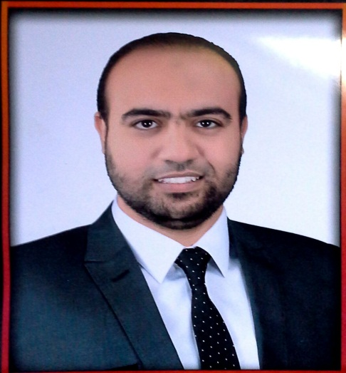
Curriculum Vitae

Personal information
First name(s) / Surname(s) | Mohammed Awaad Abdel Ati Mohammed
 | m.awaad12@yahoo.com - Mobile : 01002696459
Education and training
Dates | November 2011 →
Title of qualification awarded | Bachelor's degree in Medicine & Surgery- Excellent Degree with honour –  Sohag Faculty of Medicine- Sohag University
Dates | July 2016→
Title of qualification awarded | Master Degree in Forensic Medicine & Clinical Toxicology - Excellent Degree-  Faculty of medicine -Sohag University
Work experience
Dates | 4 April 2013 - 30 July 2016
Occupation or position held | Demonstrator in Forensic Medicine & Clinical Toxicology Department-  Faculty of Medicine - Sohag University-Egypt.
Dates | 01 August 2016 →
Occupation or position held | Assistant lecturer in Forensic Medicine & Clinical Toxicology Department-  Faculty of Medicine - Sohag University-Egypt.

